# Homework 6: User Management

# Task 4. Assigning User Mappings to Fixed Database Roles

## A. Assigning a user to a database role

## B. Verifying the results

5) Does it fail? Show the result in a screenshot. Describe your observation and explain why it fails.

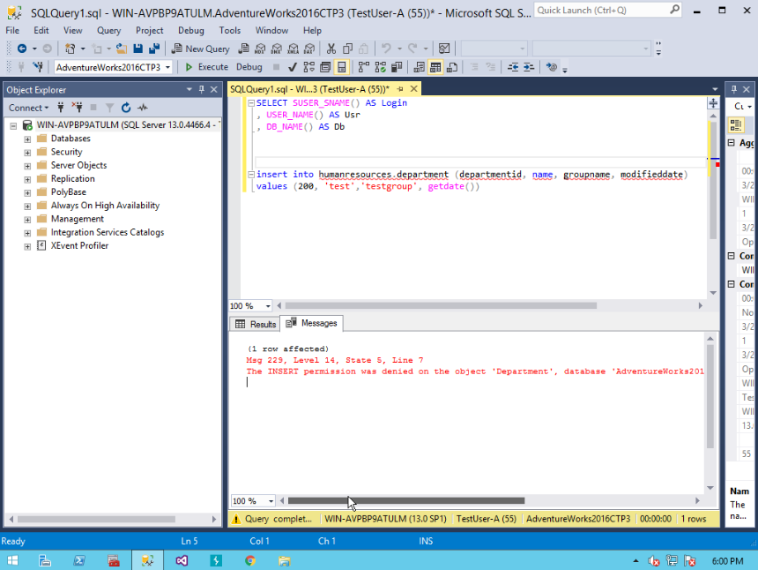

**I noticed the database Human resources wasn’t accessed since the name we use isn’t that database and the use of department isn’t a part of this database as well**

10) Does it fail? Show the result in a screenshot. Describe your observation and explain why it fails.

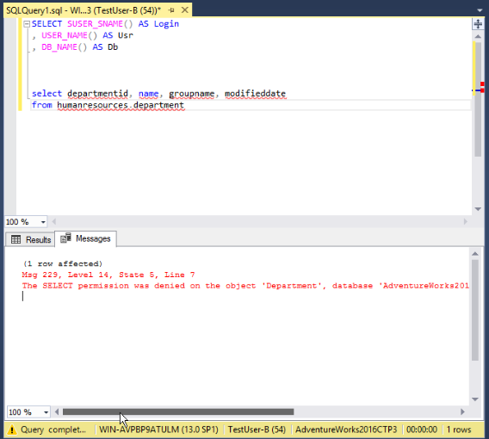

Test User B doesn’t have access to select from the department database and has the same issue as the first problem.

# Task 5. Creating a Custom Database Role

## A. Creating a custom database role

## B. Verifying results

4) Does it work? Show the result in a screenshot. Describe your observation and explain why it works.

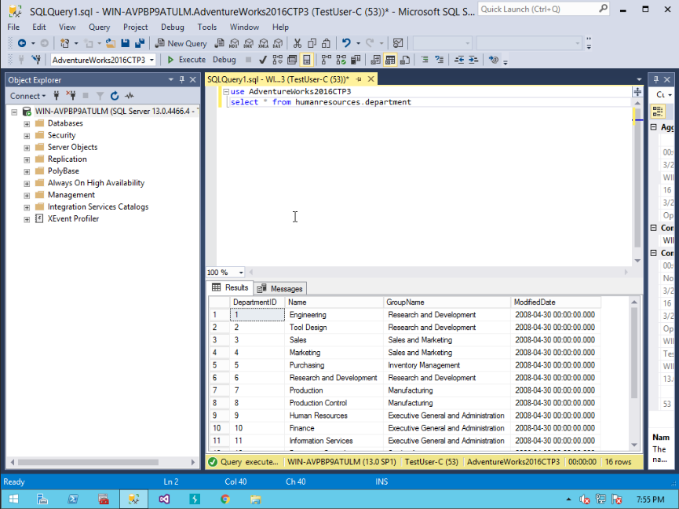

This works because it uses the adventureworks2016 database to pull the data from.

5) Does it fail? Show the result in a screenshot. Describe your observation and explain why it fails.

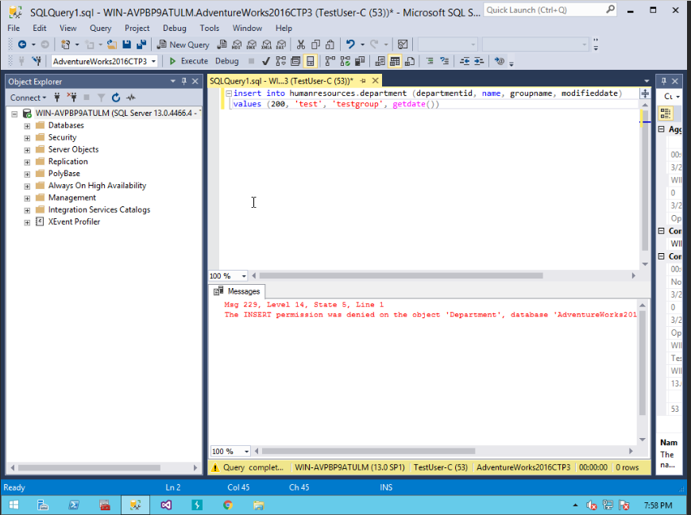

It’s not pulling from the database and has no permission to alter the data in the database.

# Task 6. Creating an Application Role

## A. Creating an Application Role

## B. Verifying Results

2) Does it fail? Show the result in a screenshot. Describe your observation and explain why it fails.

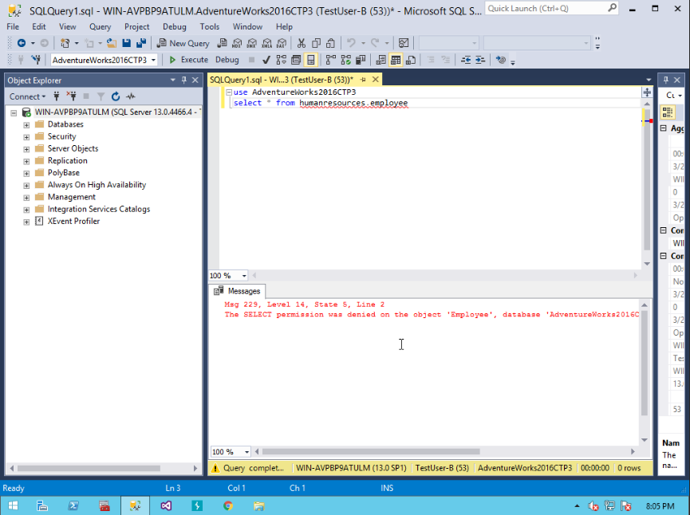

The user isn’t granted the select permission

4) Does it work? Show the result in a screenshot. You have to click on Results to view the results. Describe your observation and explain why it works.

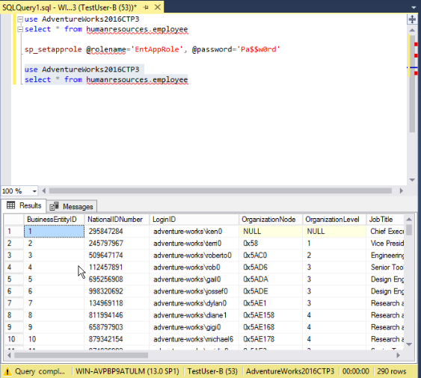

The set app role command allowed the user to be granted the select permission.

# Task 7. Assigning Permissions

9) Does it work? Show the result in a screenshot. Describe your observation and explain why it works.

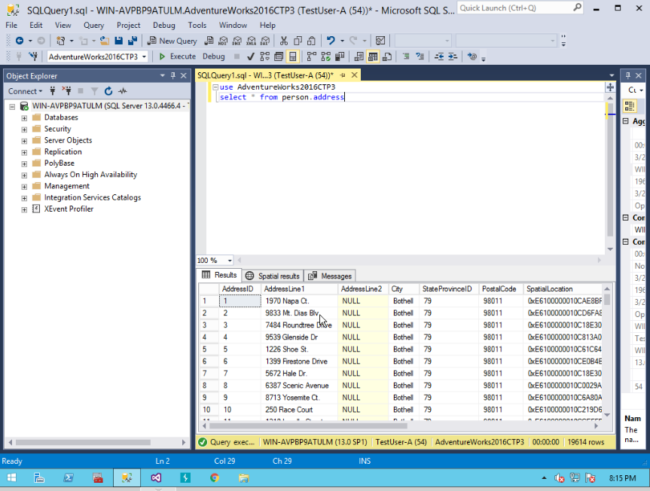

Test User A has been granted the select permission

13) Run the previous query. Show the result in a screenshot. Describe your observation and explain why it fails.

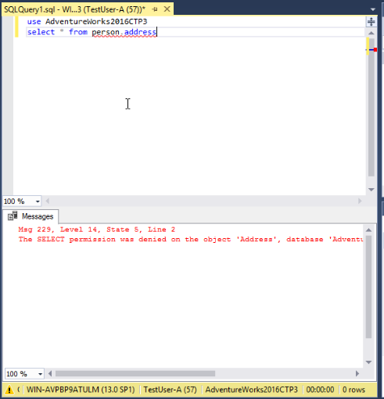

The select permission was revoked from user A

15) Run the previous query. Show the result in a screenshot. Describe your observation and explain why it works.

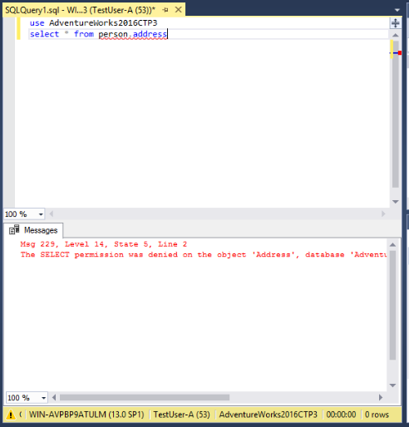

Data reader is enabled but doesn’t allow the select command

19) Run the previous query. Show the result in a screenshot. Describe your observation and explain why it fails.

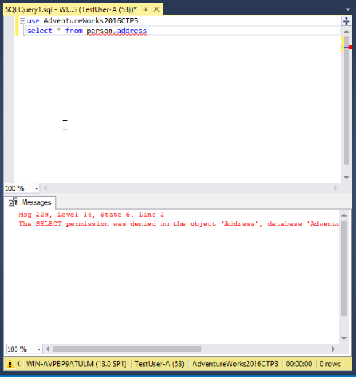

The Test user is denied from accessing the database